TEAM PROJECT PRESENTATION PROTOCOL
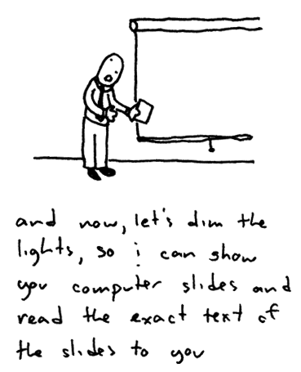
- Present the Project!
  - Project title
  - Description of the project
  - The 6 A’s of Designing Projects (Academic Rigor, Authenticity, Applied Learning, Active Exploration, Adult Connections, Assessment Practices) to unveil further facets and process of the program. Make sure you include the kinds of support and feedback that students will receive criteria for success and how students will present their project).

- Burning Questions!
- Presenters ask questions of participants that they would like to have answered or discussed (input questions, example, what do you think of our time frame? Anyone have ideas on who the students can present their information to outside of our student body?)

- Clarifying and Probing Questions:
- Participants ask clarifying questions about the project; these questions should be simple enough to answer with a yes or no response.
- Participants ask questions in an effort to understand better the presenters’ thinking, decisions and purposes.

- Discussion:
- Presenting teachers don’t speak for this part…it is only about the project now!
- I like….
- How about…
- Is the project worth doing—is it one that will engage all students?

- Response:
- Presenters respond, saying how they now view their project (after hearing group response)

- Participants respond to the presenters:
- What lessons did I learn for my own work?
- What am I learning from this?

