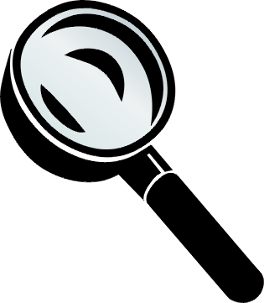
Optics: A New Perspective Name: _____________
Lesson 1 | How does light move? How are shadows formed?
I think that… | - Draw arrows to show how the light leaves the bulb pictured below.  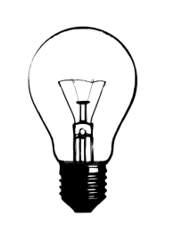  - What will the shadow of the book below look like if the desk lamp is turned on? Draw and colour in the shadow.  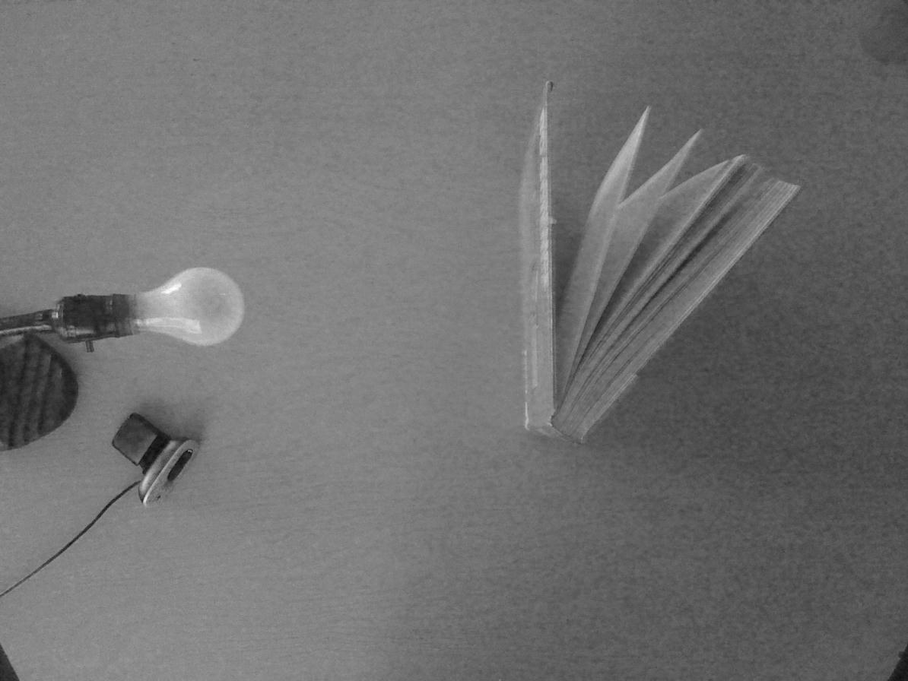  - How could you make the shadow of the object from #2 bigger?
Trying it out… | - Set up a desk lamp, textbook, and white board as shown above.  - Draw what you see in the space below, and explain how it is the same or different from your prediction.  - Move your lamp to the left or the right. How does it change the shadow of the book? Describe this, and draw what you see in the space below.  - Move your lamp closer and farther away from the apple. How does it change the apple’s shadow? Describe this, and draw what you see in the space below (from closer and farther away).
What does it mean? | Read pages 168-172 in your textbook.  - Why do scientists use the ray model of light?  - Fill in the table below to summarize the differences between objects that are transparent, translucent, and opaque.  What happens to the light Ray diagram Example(s)  Transparent  Translucent  Opaque  - Draw diagrams using the ray model of light and also explain:  - What the shadow of the book looked like when it was close to the lamp.  - What the shadow of the book looked like when it was farther away from the lamp.  - Explain why you can see a clear image of yourself in a smooth piece of aluminum foil, but not in the foil if it is crumpled. Draw a diagram too!
Big Ideas from this Lesson
Lesson 2 |  | How do reflections work?
Trying it out… |  | - Materials needed: textbook, nail, mirror, protractor, pencil, ruler  - Complete steps 1-3 on pages 178 – 179 along with the class. Work carefully and neatly on the back of this handout.  - Take your mirror, paper, pencil, and ruler to a ray box to complete steps 4 and 5.  - Complete steps 6-9 with the class.  - Complete step 10 on your own or with your partner (but you each need to complete your own paper) if time allows.
What does it mean? |  | - You drew two rays from point P to the mirror. If you had enough time, how many rays could you have drawn between point P and the mirror? (don’t draw them, just think about it and answer!)  - Extend each reflected ray behind the mirror, using a dotted line. Label the point where these two dotted lines meet as P. This is the location of the image of point P. Measure the perpendicular (at right angles) distance between:  - point P (the object) and the mirror ____________ cm  - point P (the image) and the mirror ____________ cm  c) How do these distances compare?
Big Ideas from this Lesson |  | How does the angle of reflection compare to the angle of incidence? Draw a quick sketch to go along with your explanation!
Lesson 3 |  | How do the reflections from curved mirrors work?
I think that… |  | Based on what you know about mirrors and reflections, draw the light rays bouncing off of the following mirrors:  - Plane mirror  - Concave mirror  - Convex mirror
Trying it out… |  | - Observe the class demonstration of how light rays are reflected off of a concave or convex mirror. Sketch the results in the space below. Label the focal point and focal length if possible.  - Hold the convex mirror provided directly in front of you at arm’s length and view your own reflection. Bring the mirror gradually closer to your face, focusing on one eye, and observe as the image reappears. Keep moving the mirror closer until the image of your eye reappears. Record your observations.  - Repeat steps 1 and 2 with a concave mirror. Be detailed in your observations!
The Big Idea! |  | Summarize the results of our experiments with mirrors in the following table!  Plane Mirror Concave Mirror Convex Mirror  Sketch the mirror and show what happened to three parallel light rays as they reflect off of it.  Are the reflected light rays converging (coming together) or diverging (separating)?  Describe the SIZE (enlarged or smaller) and ORIENTATION (is it right side up or upside down) of an object (such as your face/eye) of the image seen in this mirror when viewed from very close or far away. Close Close Close  Far away Far Away Far Away  Give an example or two of this kind of mirror and explain why this is the mirror to use!
Lesson 4 |  | What happens when light passes through different materials?
Trying it out… |  | Activity 1: Bent Pencil  - Place a pencil in an empty glass beaker. Observe it from the side.  - Fill the beaker most of the way with water. Observe it from the side.  - What happened? Record your observations, along with a sketch of both the empty and water-filled beakers here.  Activity 2: Penny in a Cup  - Place a penny at the bottom of a small, opaque container and set it on your desk.  - Slowly slide the penny away from you until you just lose sight of the penny.  - Without disturbing the penny or the cup or changing your own position, have someone fill the cup with water until you can see the penny!  - What happens to the path of light from the water to the air?  - Sketch the path of the light from the penny to your eye:  - Before the water was added b. After the water was added  (when you couldn’t see the penny)
What does it mean? |  | Read Pages 174-175. In the boxes below, copy figures 5.11A and 5.11B, and record the captions below them with each of your drawings.
Lesson 5 |  | How do convex and concave lenses affect light?
I think that… |  | Predict what will happen when light rays pass through convex and concave lenses continuing the light rays below.  - Convex lens  - Concave lens
Trying it out… |  | - Observe the class demonstration of how light rays are refracted by a concave or convex lens. Sketch the results in the space below. Label the focal point and focal length if possible.  - Following a second set of observations with different lenses, describe how the thickness of the lens affects how much the light is refracted.  - Use the concave lens provided to look at the words on this page. Look through it from about 20 cm away from the page, and slowly move it closer to the page. Then look at around at other things in the room. Record your observations.  - Repeat what you did in #3 with a convex lens. Be detailed in your observations!
What does it mean? |  | - Summarize what you have learned about lenses in the chart below!  Concave Lens Convex Lens  Sketch the lens and show what happened to three parallel light rays as they reflect off of it.  Are the reflected light rays converging (coming together) or diverging (spreading out)?  Describe the SIZE (enlarged or smaller) and ORIENTATION (is it right side up or upside down) of an object (such as your face/eye) of the image seen in this lens when viewed from very close or far away. Close Close  Far Away Far Away  Give an example or two of this kind of lens and explain why this is the lens to use!  - How does the thickness of a convex lens affect its focal length and why? Draw sketches with your explanation.  - Is a concave lens more like a concave mirror or a convex mirror? Explain your answer and draw sketches to support it.
Lesson 6 |  | How can I use the properties of lenses to magnify something that is far away?
Some background information! |  | Start by reading pages 219-221 to learn about refracting and reflecting telescopes. You may want to follow this up with extra research to help you in your design.
Trying it out… |  | - With the rest of your group, decide what you will need in order to build a working telescope. Experiment with the different materials provided until you come up with something that works! Make a detailed record in the space below of what you tried and what your results were.  - When you come up with a design that you think will work, build it! Make sure it is sturdy so that it can be demonstrated to your parents!  Eye Piece Lens (Type, Focal Lenth) Objective Lens (Type, Focal Length) Length to Produce and Image Magnification/ Orientation
What does it mean? |  | - Make a careful, accurate (use measurements to scale) diagram of your telescope.  - Explain how your telescope works, and be prepared to demonstrate and explain it to your parents (and to me!) Make sure that you use proper terms (refraction, converging or diverging, focal point and focal length, objective and eye piece lenses, etc).

