One Step Equations
How many pennies are in the cup (assume the cup weighs nothing)?
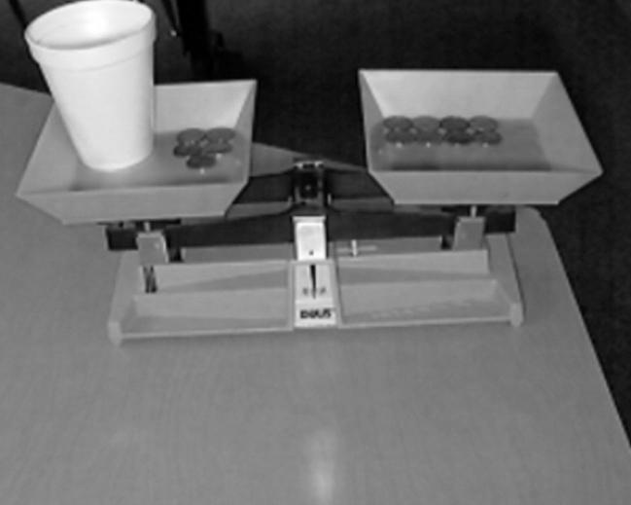  1) | 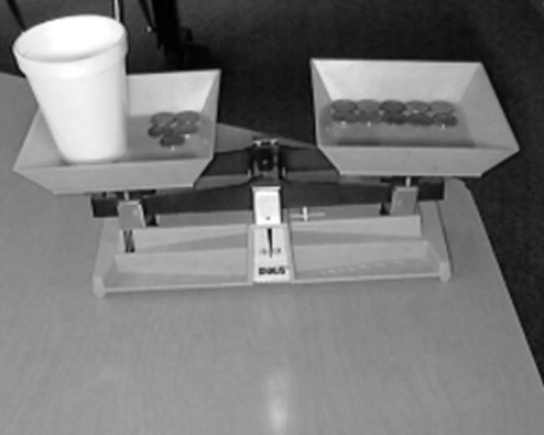  2)
__________________ | __________________
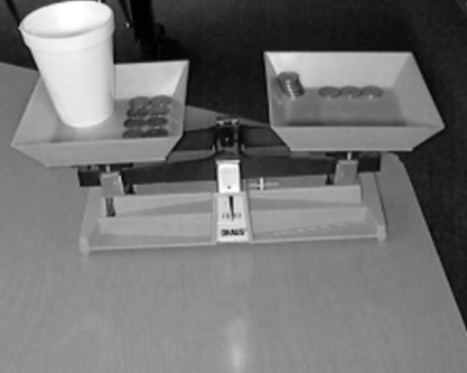  3) | 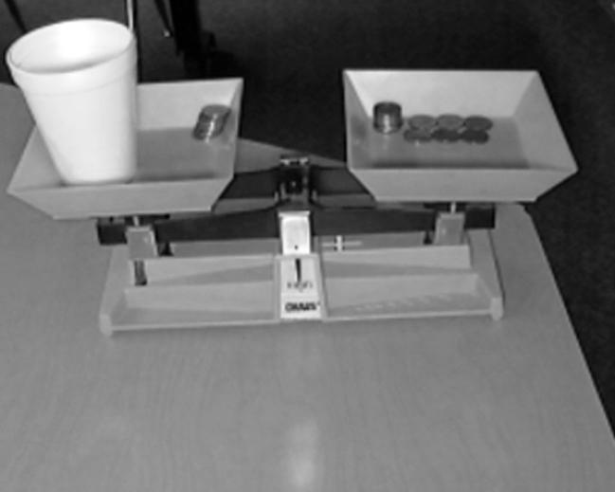  4)
__________________ | __________________
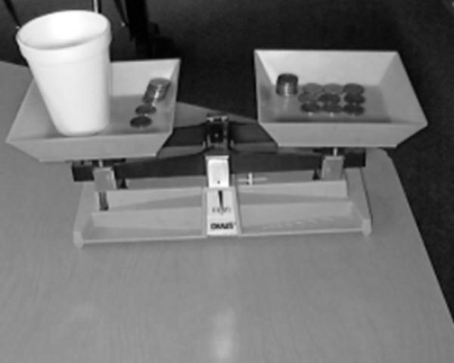
5)
__________________
Do you notice any patterns? Try your idea on these more difficult problems.
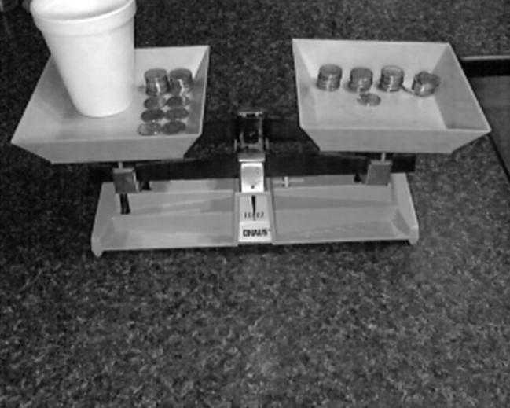 | 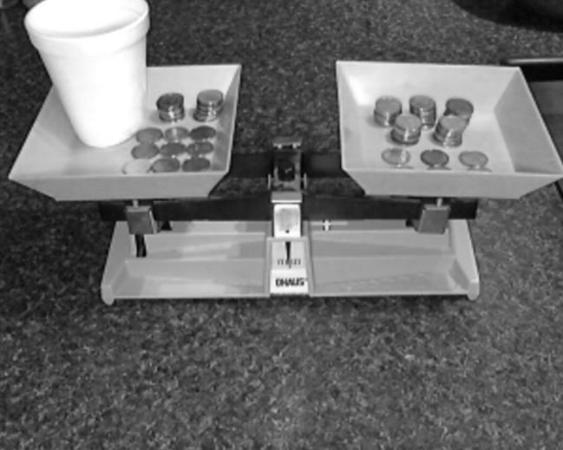
___________________ | ___________________

What did you do to solve the harder problems? Make a simple rule that you can use to solve any of these problems.
_______________________________________________________________________________________________________________________________________________________________________________________________________________________________________
Problem | Visual | Number of Pennies in the cup
On the left side there is 1 cup and 5 pennies

On the right side there is 10 pennies.
Problem | Visual | Number of Pennies in the cup
On the left side there is 1 cup and 8 pennies.

On the right side there is 10 pennies.
On the left side there is 1 cup and 9 pennies.

On the right side there is 12 pennies.
On the left side there is 1 cup and 17 pennies.

On the right side there is 23 pennies.
On the left side there is 1 cup and 195 pennies.

On the right side there is 235 pennies.

Check in with Mr. Piccini
Try it with variables instead of cups.
Problem | Verification
$$x+7=16$$

$$x=$$
$$x+7=18$$

$$x=$$
$$x+37=72$$

$$x=$$
$$x+15=32$$

$$x=$$
$$x+21=18$$

$$x=$$
$$x+35=88$$

$$x=$$
Challenges
$$x-18=27$$

$$x=$$
$$x+10.7=16$$

$$x=$$
Does your pattern work with any number? Grab your white board, find some numbers that don’t work (what different types of numbers do we know?). See if you can break the rule. Report any of your findings here…

